Guillermo Moronta Fernandez

Umbra's VEHICLE MAINTENANCE SYSTEM – 2020

Umbra's Auto Sales Inc. is the leading West Coast dealership of Phantom Motors. Although Umbra's Auto Sales gives relatively good prices for both new and used cars, it has always had a reputation for aggressive salespeople. One of the dealership strengths is its repair shop, which is recognized for both high quality service and fair prices.

When a customer brings his/her vehicle in for repair, the Service Manager [SM] determines if the customer has been in before. If a new customer, the SM adds the customer to the Customer Database, then adds vehicle information into the Vehicle database and the work order. If an existing customer, the SM looks up the customer history and updates the customer information. The SM the looks up the vehicle history. If not found, we assume the customer is driving a different vehicle. The SM adds the new vehicle the customer is currently driving. If the vehicle is found, the SM will update any pertinent information.

Once these steps are completed, the SM completes the work order with the customer, obtains information such as the description of the problem, before the customer signs the work order. The SM enters the work order information into the system. The default status for the work order at this time is ‘unassigned’.

The SM reviews the work order to determine what type of work needs to be performed to repair the vehicle. The Service Manager then accesses the mechanic file, which contains information about the specialty of each mechanic. The SM invokes the system to provide him a list of mechanics with the specialties needed to complete this specific work order. Once the SM has chosen which mechanics are to be assigned the work order, the SM invokes the system to update the work order with the employee number of each mechanic, change the status of the work order to ‘assigned’, and send an electronic copy to the assigned mechanics.
The assigned mechanic examines the vehicle to verify that the problem diagnosed by the Service Manager is on point. If there are additional areas of concern, the mechanic provides cost and time estimates on the work order, then contacts the SM, who calls the customer with the revised estimate to fix the vehicle and verbal approval to perform the additional work.

If the customer refuses to have the additional work done, the SM informs the mechanic who makes note of the customer refusal on the work order. If the customer approves the additional work, the SM informs the mechanic who notes the customer approval on the work order.

The mechanic goes to the Parts Department to obtain the needed parts to fix the vehicle. For the sake of this case, assume that all parts are in stock, and you do not need to add or edit any parts. The mechanic enters the part numbers, the respective quantities needed, and the work order number to against which to charge the adjustment in the Parts inventory. The system automatically updates the work order after the parts inventory has been adjusted.

For the work order in progress, each mechanic assigned to the work order records the time spent and parts used to complete their portion of the task. Once the repairs are completed by all the assigned mechanics, the last mechanic to work on the vehicle ‘closes’ the work order.

This ‘closed’ work order status change prompts the SM, who reviews the repairs, provides additional comments as needed, completes all cost information and verifies the total. The Service Manager updates the status of the work order to ‘approved’ and reviews the repairs and total with the customer. The customer pays for the repairs, is provided a receipt along with a copy of the work order, obtains their keys, and drives off.

Required:

[1] Draw the USE CASE DIAGRAM for this case [10]

[2] Create the related USE CASE NARRATIVES [40]
Do Not Create a Narrative for LOOKUP

[3] Draw the related SEQUENCE DIAGRAMS [40]
Do Not Create a Sequence Diagram for LOOKUP

[4] Create a single CLASS DIAGRAM for the system under review [10]
USE CASE DIAGRAM
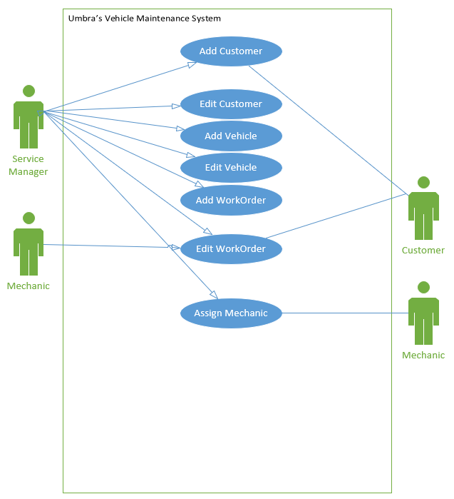

Use Case Name: | Add Customer
Description: | Adds customer to the database in the event that the customer isn’t an already existing one.
Actor(s): | Service Manager
Preconditions: | The customer must be a unique entry to the system
Trigger: | Customer not already present in the database brings in their vehicle for a repair
Normal flow of events: | Actor action | System Response
Normal flow of events: | .1 Service Manager enters customer information for a new and unique entry | 2. The system returns confirmation of the customer being added
Alternate flow of events: | n/a | n/a
Post-conditions: | A new customer is added to the system
Outstanding Issues: | n/a

Sequence Diagram
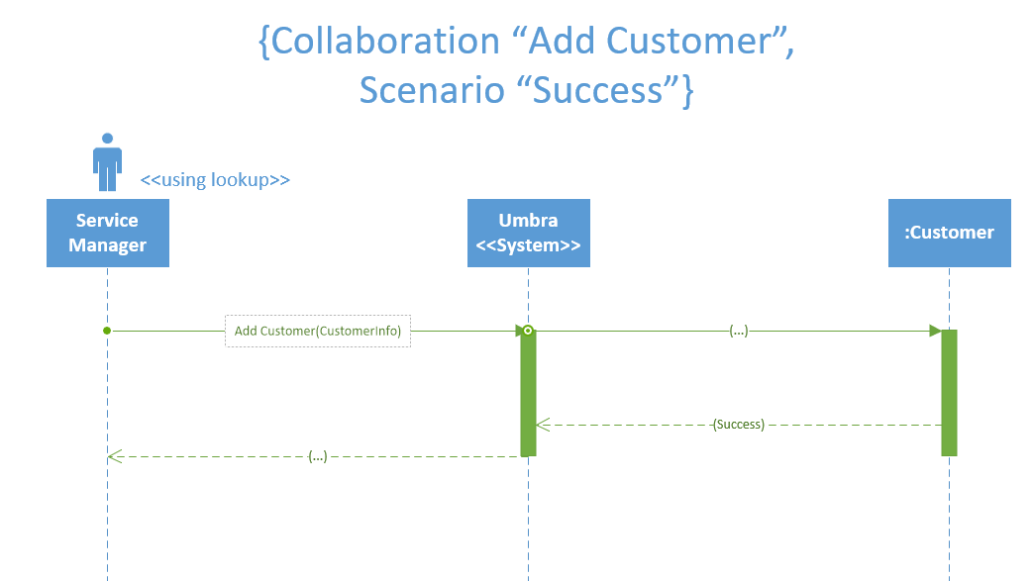

Use Case Name: | Edit Customer
Description: | An existing customer within the system has its information updated
Actor(s): | Service Manager
Preconditions: | An existing customer has information that needs to be changed
Trigger: | An existing customer makes a repair request and has information that must be changed.
Normal flow of events: | Actor action | System Response
Normal flow of events: | - The service manager looks up the existing customer within the system  - The relevant selected is made, and the information is changed and then updated. | - The system returns confirmation of the edited and saved customer changes.
Alternate flow of events: | n/a | n/a
Post-conditions: | This existing customer has their information edited
Outstanding Issues: | n/a

Sequence Diagram
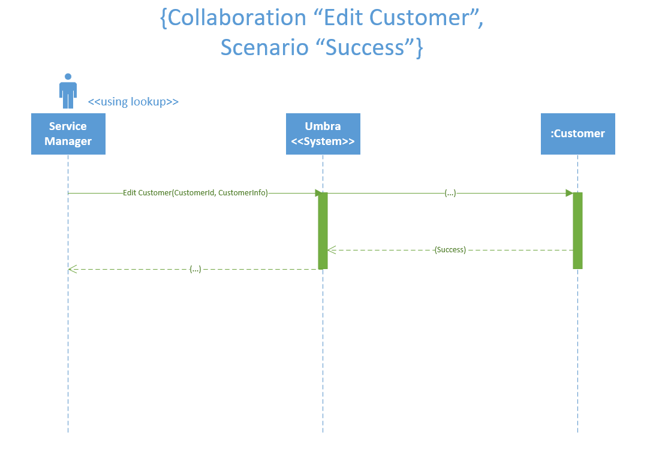

Use Case Name: | Add Vehicle
Description: | A new vehicle is added when the customer’s existing vehicle information (or perhaps a new customer) is not already in the system
Actor(s): | Service Manager
Preconditions: | A customer’s vehicle information is not present within the system when brought in for repairs
Trigger: | A customer brings their vehicle and requests a repair
Normal flow of events: | Actor action | System Response
Normal flow of events: | - Service Manager enters vehicle information for a new and unique entry | - The system returns confirmation of the vehicle being added
Alternate flow of events: | n/a | n/a
Post-conditions: | The new vehicle information is added to the system
Outstanding Issues: | n/a

Sequence Diagram
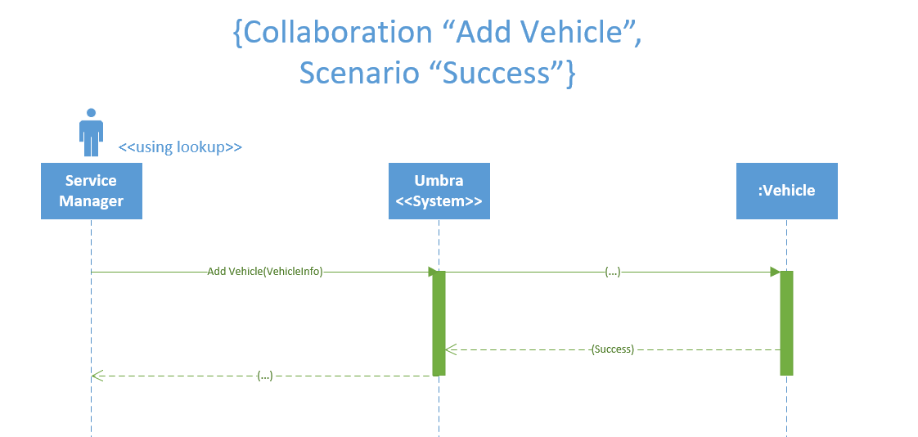

Use Case Name: | Edit Vehicle
Description: | An existing customer vehicle is edited when brought in for repair and new information must be added.
Actor(s): | Service Manager
Preconditions: | The vehicle already exists within the system and was brought in for repair by a customer
Trigger: | Customer makes a repair request with a vehicle existing within the system
Normal flow of events: | Actor action | System Response
Normal flow of events: | - Service Manager looks up an existing vehicle within the system  - Service Manager selects the vehicle and updates the information | - The system returns confirmation of the vehicle changes being saved.
Alternate flow of events: | n/a | n/a
Post-conditions: | The existing vehicle’s information is updated
Outstanding Issues: | n/a

Sequence Diagram
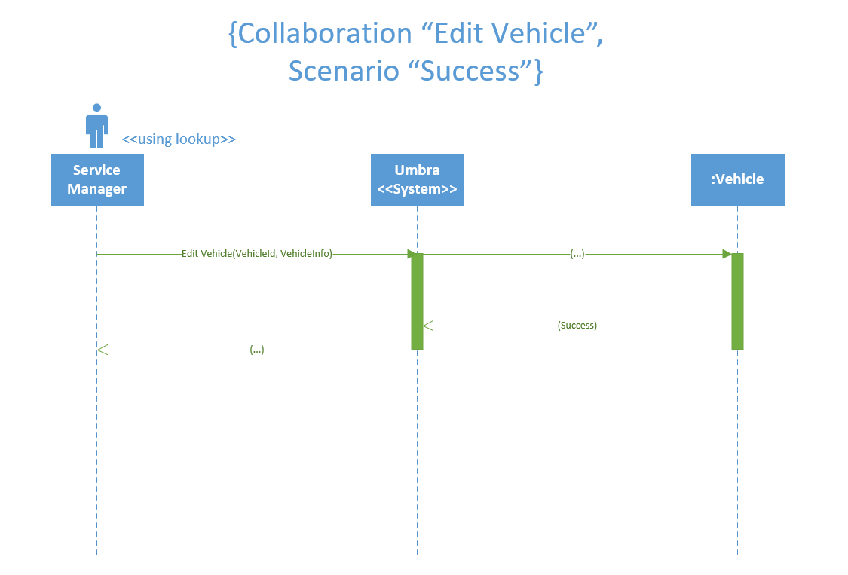

Use Case Name: | Add WorkOrder
Description: | The initial workorder is created in the system
Actor(s): | Service Manager
Preconditions: | The workorder being created is a new and unique entry into the system
Trigger: | Customer brings vehicle in for a NEW repair.
Normal flow of events: | Actor action | System Response
Normal flow of events: | - A new and unique work order entry is created and the Service manager enters preliminary issues as provided by the customer what a status of unassigned | - The system returns confirmation of the new workorder being created
Alternate flow of events: | n/a | n/a
Post-conditions: | New work order is created
Outstanding Issues: | n/a

Sequence Diagram
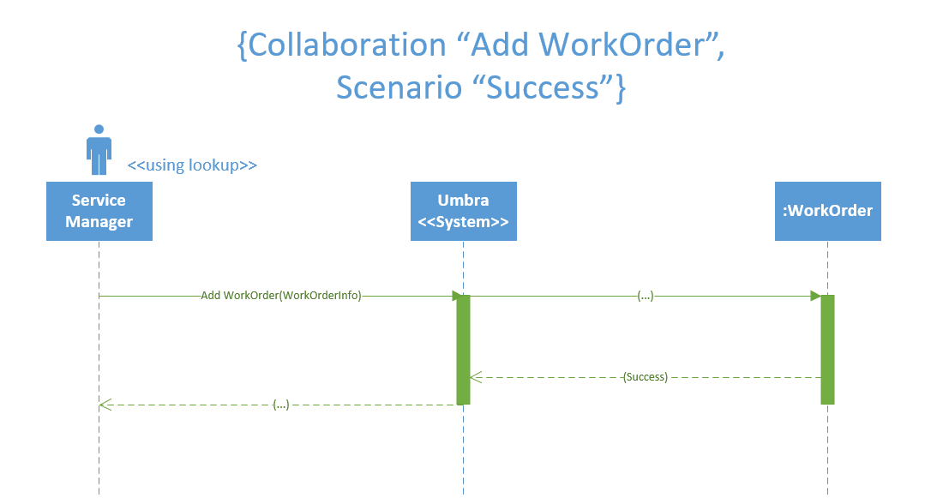

Use Case Name: | Edit Work Order
Description: | An existing work order is updated to reflect changes in the repair process or to mark a work order as ‘approved’.
Actor(s): | Service Manager, Mechanic
Preconditions: | An existing work order is already in the system and is having its information changed
Trigger: | Mechanic revises the existing workorder, Service Manager changes the status of a work order to ‘approved’
Normal flow of events: | Actor action | System Response
Normal flow of events: | - Actor updates information within an existing workorder | - System returns confirmation of the work order being updated
Alternate flow of events: | n/a | n/a
Post-conditions: | The workorder’s information is changed
Outstanding Issues: | n/a

Sequence Diagram
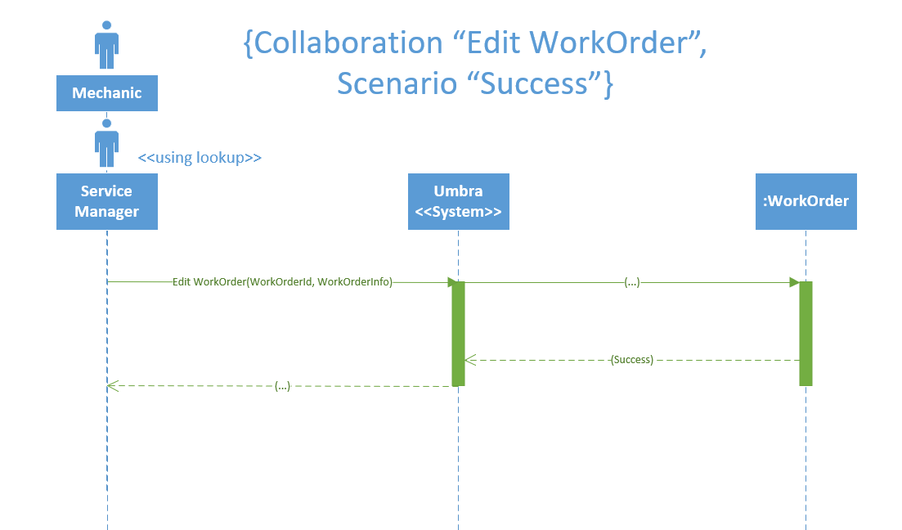

Use Case Name: | Assign Mechanic
Description: | The service manager assigns relevant mechanics to a work order
Actor(s): | Service Manager
Preconditions: | A workorder with a status of ‘unassigned’ exists within the system
Trigger: | A workorder was created and the service manager assigns mechanics to the workorder
Normal flow of events: | Actor action | System Response
Normal flow of events: | - Service manager queries for a list of mechanics  3. The service manager assigns mechanics relevant to the workorder, and then updates the workorders | - System returns a list of mechanics  4. System confirms the assigned mechanics and sends out an electronic copy of the work order
Alternate flow of events: | n/a | n/a
Post-conditions: | Mechanics are assigned to a workorder and given electronic copies of it
Outstanding Issues: | n/a

Sequence Diagram
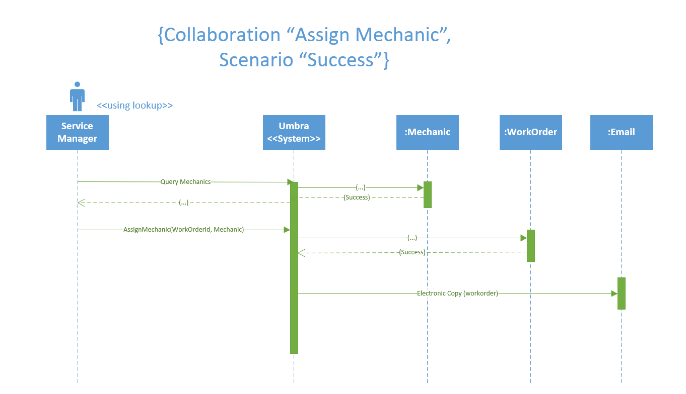

Use Case Name:
Description:
Actor(s):
Preconditions:
Trigger:
Normal flow of events: | Actor action | System Response
Alternate flow of events:
Post-conditions:
Outstanding Issues:

Sequence Diagram

Use Case Name:
Description:
Actor(s):
Preconditions:
Trigger:
Normal flow of events: | Actor action | System Response
Alternate flow of events:
Post-conditions:
Outstanding Issues:

Sequence Diagram

Use Case Name:
Description:
Actor(s):
Preconditions:
Trigger:
Normal flow of events: | Actor action | System Response
Alternate flow of events:
Post-conditions:
Outstanding Issues:

Sequence Diagram
Class Diagram

